The model introduces a new quantitative framework called QBowtie to classify and assess cyber risk. It combines a bow-tie model depicting causal risk relationships with a risk matrix approach to quantify likelihood and severity.

A bow-tie model visualizes a risk scenario with threats on one side that can lead to a cyber incident, and consequences on the other side showing the impacts. Barriers can reduce the likelihood of threats, while escalators increase it. The framework identifies 5 key cyber threat categories based on claims data, including hackers, malware, insiders, lost devices, and vulnerabilities. It also identifies 4 major consequence categories: business interruption, financial loss, reputation damage, regulatory fines.

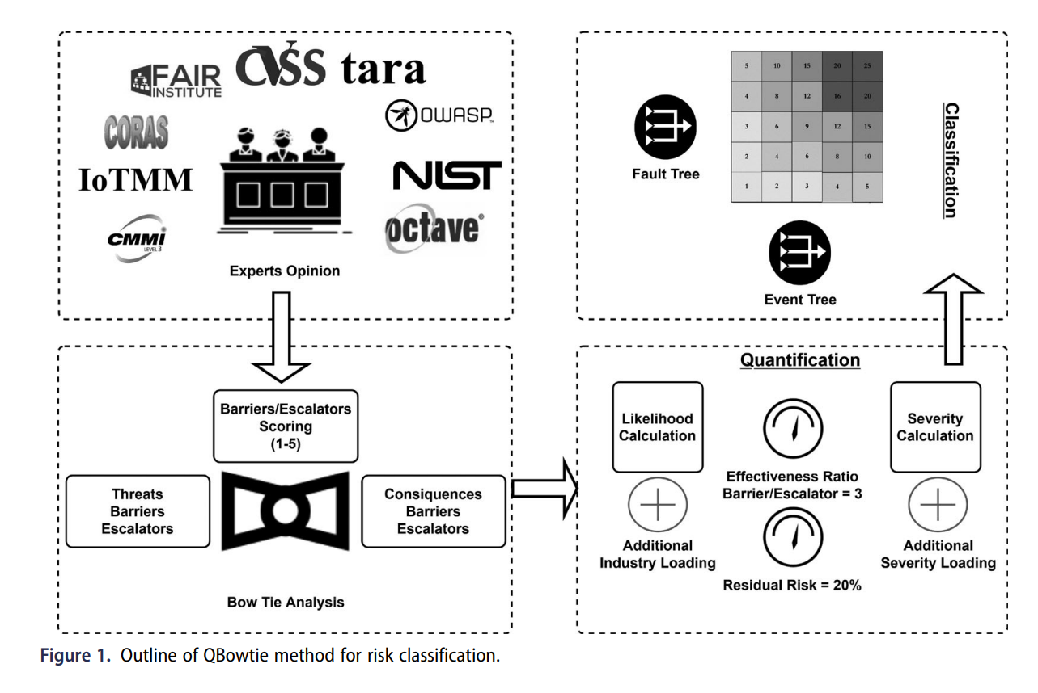

Experts score the effectiveness of specific barriers and escalators for each threat and consequence category on a 1 to 5 scale. These scores are tabulated and input into the bow-tie model. The median score is used for each barrier and escalator, as this is most reliable for small expert samples. Industry loadings are added based on cyber claims frequency data. Mathematical calculations quantify overall likelihood and severity scores from 0.2 to 1.0.

A 5x5 risk matrix combines the likelihood and severity ratings to determine the overall cyber risk rating from 1 to 25. This visualizes the risk level, from low to high. Advisory information helps companies improve their rating.

The QBowtie framework combines bow-tie analysis and risk matrices to provide an intermediate semi-quantitative approach for classifying cyber risk. It produces an indicative cyber risk rating scale using expert input until sufficient statistical data becomes available. Both insurers and companies can benefit from the actionable risk visualization and insights it provides.

Approach: -

1. Gathering details on specific barriers and escalators employed at the respective domain from an IT manager who works there.

2. Tabulate the chosen domain barriers and escalators for each threat and consequence category.

3. Enter the data into the QBowtie model's bow-tie diagrams for threats and consequences.

4. Calculate the likelihood score from the threat analysis.

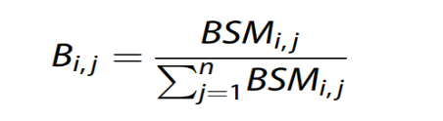

4.1 Bij is the weighted barrier score for ith threat in jth category.

BSMij is the expert barrier score median for the ith threat category and jth barrier.

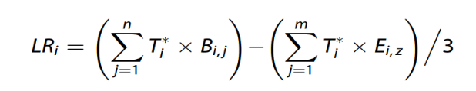

4.2 Reduction in the threat likelihood can be formulated by the above formula where Ti\* represents ith threat allowing for the residual risk.

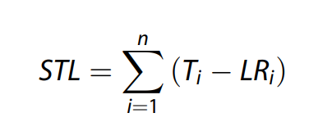

4.3 The above formula is used to calculate the sum of the threat likelihood

5. After the threat analysis the sum of the individual consequence severity (SIS) is calculated using the below formula.

